## horizontal line



Team Project Terms of Reference

Assignment 1 - KF6002 - Team Project - 17/02/2020

Ben Rowell - 19032995

Joseph Kelieff - 19034959

Nathan Robinson - 19023551

Alarah Robinson - 19023550

Andrew Penman - 19023545

**Project Scope** **3**

1.1 Group Scope 3

1.2 Individual Scope 4

1.2.1 Joseph Kelieff - Admin Subsystem 4

1.2.2 Ben Rowell - Create Rota Subsystem 5

1.2.3 Nathan Robinson - Rota Request Subsystem 6

1.2.4 Andrew Penman - Staff Rota System 7

1.2.5 Alarah Robinson - Rota Alteration 9

**2. Research Plans** **10**

2.1 Common Research Plan 10

2.2 Individual Research Plans 10

2.2.1 Joseph Kelieff - Admin System 10

2.2.2 Ben Rowell - Create Rota Subsystem 11

2.2.3 Nathan Robinson - Rota Request Subsystem 11

2.2.4 Andrew Penman - Staff Rota System 11

2.2.5 Alarah Robinson - Rota Alteration subsystem 12

**3. Project Completion Plan** **12**

3.1 Group Tasks and Deliverables 12

3.1.1 Requirements Capture 12

3.1.2 Analysis and Design 12

3.1.3 System Building 13

3.1.4 Gantt Chart, Testing & Configuration & Integration 13

3.1.5 Project Costing 13

**4. Legal, Social, Ethical and Security Aspects of Subsystem** **15**

4.1 Joseph Kelieff - Admin System 15

4.1.1 Legal 15

4.1.2 Social 16

4.1.3 Ethical 16

4.1.4 Security 16

4.2 Ben Rowell - Create Rota Subsystem 17

4.2.1 Legal 17

4.2.2 Social and Ethical 17

4.2.3 Security 17

4.3 Nathan Robinson - Rota Request Subsystem 18

4.3.1 Legal 18

4.3.2 Social And Ethical 18

4.3.3 Security 18

4.4 Andrew Penman - Staff Rota Subsystem 19

4.4.1 Legal 19

4.4.2 Social and Ethical 19

4.4.3 Security 20

4.5 Alarah Robinson- Rota Alteration subsystem 21

4.5.1 Legal 21

4.5.2 Social and Ethical 21

4.5.3 Security 21

**5. References** **22**

**6. Appendices** **24**

6.1 Appendix A 24

6.2 Appendix B 25

6.3 Appendix C 25

6.4 Appendix D 25

6.5 Appendix E 26

6.6 Appendix F 26

6.7 Appendix G 27

6.8 Appendix H 27

6.9 Appendix I 28

6.10 Appendix J 28

6.11 Appendix K 29

6.12 Appendix L 29

# 

# Project Scope

## 1.1 Group Scope

The proposed system is a rota management system for both staff and managers within a local bar/restaurant within the area. The system will handle all issues and requirements that are needed within the business regarding the creation, alteration and organisation of rotas alongside the requesting and approval of holiday and day off requests. The system will involve 5 subsystems these are;

|  |  |  |
| --- | --- | --- |
| **Subsystem** | **Description** | **Peer Overlooking** |
| Rota Creation | This is where new rotas will be created and published to all staff members | Ben Rowell |
| Rota Alteration | This is where management can alter rotas that have already been published | Alarah Robinson |
| Staff Rotas | This is where staff members can view any published rotas and submit rota or holiday requests | Andrew Penman |
| Rota Requests | This is where managers can view, approve or deny staff submitted rota requests | Nathan Robinson |
| Admin System | Management can add, remove or edit staff/managers details | Joseph Kelieff |

The rota management system will share a common login screen for all subsystems, following this will be 2 homepages, one for staff and one for management. These will all be created by the group. The system will also contain a shared database that will contain staff information, published rotas and approved rota requests.

## 

## 1.2 Individual Scope

### 1.2.1 Joseph Kelieff - Admin Subsystem

The subsystem that I shall be creating will be the Administration System for the project. This subsystem will include three must’s that are Add New Staff Member, Add New Management Member and Assign Username to Staff and Management. It will also include one should that is Alter Staff and management Information and one could that shall be Remove Staff and Management Members. This subsystem will be required to ensure that each member of the business can access the rota securely by their own login that will not be known to any other person.

|  |  |  |
| --- | --- | --- |
| Requirement | Brief Description | Priority |
| Add New Staff Member | Allows Admin to add new staff member to the system | MUST |
| Add New Management Member | Allows Admin to add new Management member to the system | MUST |
| Assign Username To Staff and Management | Allows Admin to assign Usernames to staff and Management members within the system | MUST |
| Alter Staff and Management Information | Allows Management to alter all information of members within the business | SHOULD |
| Remove Staff & Management Members | Allows Management to remove staff or management members who have left the business | COULD |

### 

### 1.2.2 Ben Rowell - Create Rota Subsystem

This subsystem will be accessed by managers within the business and is used to create new rotas for the upcoming weeks. The system will allow the manager to select a day before displaying the shifts that need assigned for that day. By clicking on a day the manager will be shown a list of available staff members who do not have any approved rota or holiday requests. Once all empty shifts have been allocated to staff members the day can be completed, once a full week has been completed the manager can then publish the rota which will allow staff members to see their rota through their subsystem. The system will have a minimum of 3 must, 1 should and 1 could requirements.

|  |  |  |
| --- | --- | --- |
| Requirement | Brief Description | Priority |
| Create a new rota | Allows the manager to begin the creation of a new rota | Must |
| Complete all aspects of a rota | Allows the manager to complete the rota by selecting days of the week and then assigning staff members to the required shifts | Must |
| Publish/Save Rota | Allows a manager to publish a completed rota | Must |
| Alter the length of a shift | Allow management to alter the length of a shift if necessary | Should |
| Hide staff with approved rota requests from shift assignment | When a manager is selected a staff member to assign to a shift any staff with approved rota requests will not be visible to the manager | Could |

### 

### 1.2.3 Nathan Robinson - Rota Request Subsystem

The rota request subsystem which i will be creating will be accessed by managers within the company. The managers will access this system to view requests submitted by staff members. They will also need to approve or deny these requests based on the suitability of the request. Requests that managers will have to deal with include holidays, days off, unpaid leave and shift requests. The manager will view a request and once they have checked the suitability of the request they will either approve or deny the request. A notification will be sent to the specific staff member who made the request to notify them if their request has been approved or denied. The rota request subsystem will contain at least 3 Must, 1 Should and 1 Could requirements.

|  |  |  |
| --- | --- | --- |
| Requirement | Brief Description | Priority |
| Management can view submitted requests | When a manager accesses this subsystem they must be able to view the request submitted by a staff member | MUST |
| Management can check request availability/suitability | Once a manager views a request, they will check the availability and suitability depending on the type of the request. If it is a holiday, day off or time off request the manager will need to check if there is enough staff to cover or how many people have currently asked for a specific day off, holiday etc. | MUST |
| Management can approve and deny requests | Managers must be able to approve and deny requests | MUST |
| Notification sent to staff member | Once a manager has approved or denied the request, a notification should be sent to staff members to notify them if there request has been approved or denied | SHOULD |
| Notification when request is made by staff member | When a staff member makes a request, a notification could be sent to the manager so they know they have a request to either approve or deny | COULD |

### 1.2.4 Andrew Penman - Staff Rota System

The subsystem that I will be designing and implementing is the Staff Rota System, it will be obligatory for all staff members within the company to be able to access their individual rotas at any given time hence to avoid any confusion. The staff members rotas will be published within a 2 week window before the dates displayed on the rota. This will give the staff members time to check over the proposed dates and times that have been assigned to them just in case a worker can’t work on a specific date due to other commitments. If a staff member wants to request a holiday they will do so through this subsystem, it will be available for a staff member to submit a holiday request form at any time this will make the subsystem more accessible, however, the request will only be approved or declined during working hours by a manager. It is suggested that a staff member gives a valid reason for their pending holiday request although it’s not compulsory. Below I will create a table that will contain at least a list of 3 must, 1 should and 1 could for the Staff Rota System requirements.

|  |  |  |
| --- | --- | --- |
| Requirement | Brief Description | Priority |
| Staff members can view current rotas | A staff member must be able to view their current and upcoming scheduled rotas on this subsystem without any issues occuring. | MUST |
| Staff members submitting a holiday request | When using this subsystem it is a must that all staff members can submit a holiday request which will then be sent to the rota request sub system. | MUST |
| Request Day Off | Before a rota is created a staff member can request a day off, this request must be submitted to a manager which will then be either approved or declined | MUST |
| Staff members being able to view coworkers timetables | When a staff member is viewing their timetable it may be possible to implement coworkers timetables alongside their timetable, this will become useful if a worker wants to change shifts with another worker. | SHOULD |
| Holiday request tracker/Day off request tracker | When a staff member submits a holiday request or applies a day off it could be possible to add a tracker to see how far the request has gone, by doing this staff members could always see what stage the request is at. | COULD |

### 

### 1.2.5 Alarah Robinson - Rota Alteration

The subsystem I am creating is rota alteration, this will be accessed by management. This subsystem will allow management to alter any rota that has previously been published. Hence assigning shifts to staff members that may not currently be scheduled in and adding days off within the rota. This will be done by the system displaying the already published rotas, allowing the manager to choose a shift and then make any desired changes. Once any alterations have been made the system should alert staff members with the updated rota. The system will contain at least 3 must, 1 should and 1 could requirements.

|  |  |  |
| --- | --- | --- |
| Requirement | Brief description | Priority |
| Management can select published rotas | When management are accessing this subsystem, they will be able to see and select already published rotas for upcoming weeks | Must |
| Management can alter published rotas | Once management has selected a rota they should be able to make alterations. The changes will need to be made if a request has been approved, a day off is required, shift swap with another colleague is required or if the colleague cannot work on the day they have been previously assigned | Must |
| Management can save the alterations | Once management have made the alterations, the system should allow them to save the changes | Must |
| Staff alerted with alterations made to rotas | Once management have saved the rota, a notification should be sent to staff to alert them on alterations made | Should |
| Staff with approved requests or staff who cannot work on specific days will be completely hidden from manager | When a manager is making an alteration to a rota, staff who cannot work on that specific week or day could hidden from the manager to avoid more rota issues | Could |

# 2. Research Plans

## 2.1 Common Research Plan

The company that was involved from the first semester has decided to join us as a consultant to allow us to get a better idea of what a potential business would require for a system such as ours. We have decided to continue to conduct interviews (See Appendix A) with the management there to ensure that our system would be tailored to a restaurant/bar to better get control over their business.

To better prepare for creating a system of this scale, background research has been undertaken to identify potential existing systems that may have the same features, prepare a set of standards, any stakeholder groups and any relevant literature alongside this kind of system that will be created.

There are two systems currently that offer the same service where our system will currently provide. Findmyshift (2020) provides a rota creation which will allow an establishment to enter staff manually or import them from another app which would allow a smoother transition from an entire system that was previously used before. Findmyshift (2020) also allows management to forward plans for the entirety of the businesses staff for £22 per month which will also allow for the company to expand the staff number if necessary. Deputy (2020) also provides these services though within a much simpler format with colour co-ordination and allows management to verify the timesheets of each individual employee while also allowing communication amongst staff through this system. Deputy (2020) also shows us that swapping shifts is easier through this system as it is quick and will also let management know when this happens right away as well.

## 2.2 Individual Research Plans

### 2.2.1 Joseph Kelieff - Admin System

This subsystem will be the backdrop of the entire project which will endeavor to hold the information of the staff and management while also creating the account for each individual member. If a staff or management member were to leave the business they can also be taken off the system to better control who has the right to use the system.

To further get a better idea of what a business may want for this specific subsystem I have decided to conduct an interview (See Appendix B) to ensure that the aspects of the admin subsystem to effectively decide which factors would need to be integrated and what may be of lesser value or not needed entirely.

### 2.2.2 Ben Rowell - Create Rota Subsystem

This subsystem was previously explored within Semester 1 therefore the overview of this subsystem has already been explored. However this overview does not provide enough detail for the subsystem to be created. Details are still missing such as how many staff are usually on each shift and how many departments work each shift. To research and establish the finer details such as this an interview will be conducted between myself and a manager who has previously created a various rotas for the organisation. A template of the questions that were asked are located in Appendix C.

### 2.2.3 Nathan Robinson - Rota Request Subsystem

Research on the rota request subsystem was previously carried out within Semester 1. Interviews and observations were carried out to gather research on this subsystem within Semester 1. However, there are definitely some details missing which must be gathered before building this subsystem. I will need to carry out a further interview with the manager of the company to establish finer details to build an efficient rota request subsystem. Interview questions which I will conduct with a manager of the company can be seen in Appendix D.

### 2.2.4 Andrew Penman - Staff Rota System

The staff rota subsystem can come advanced pretty quickly when compiling everything, it will be wise for me to do extensive research on this subsystem so the whole system runs efficiently. There are many different resources when it comes to gather information on this topic, the sources that I think will be best to use are:

Using the internet - I will use the internet to gather information about previously designed staff rota systems that have come to fruition. This will be a good idea because I'll be able to see what makes a fully functioning system and an inept system benefiting me when it comes to implementing the system.

Questionnaire - I could potentially design a questionnaire about what changes the staff members would like to see on the new system and anything they would like to keep from the old and outdated system. This could boost staff morale as they would have a voice in what the new system looks like. (See Appendix E)

Interview for management - After all the questionnaire answers have been thoroughly reviewed I think it will be best to conduct an interview with the management of the company this will be done to gather further information about the company and feedback information that has been gathered from the staff questionnaire. (See Appendix F)

### 2.2.5 Alarah Robinson - Rota Alteration subsystem

The subsystem rota alteration was already explored via semester 1. I found that there were not sufficient observations or interviews conducted to create a fully functioning subsystem. In order to create a well established rota alteration subsystem, I will need to perform some extensive research. This will be achieved by conducting an interview between myself and the manager, this will allow me to develop a further understanding of what requirements the manager wants for the rota alteration subsystem. See Appendix G, for the interview questions i will use to gather the relevant information.

# 3. Project Completion Plan

## 3.1 Group Tasks and Deliverables

### 3.1.1 Requirements Capture

Requirements capture for the overall system has previously been completed during a design module in semester 1. This requirements capture provided an overview of the system and the general requirements of the rota system however did not provide any details into the specifics needed to create a rota system. In order to overcome this further requirements capture has been undertaken in order to provide specifics for each of the 5 subsystems which will allow the team to develop the overall system. The requirement captures that has been undertaken is discussed in more detail in the individual research plans above and show below in Appendix B.

### 3.1.2 Analysis and Design

To better get an idea and ensure that the website that we are creating will have a theme throughout the entire site we have decided to design wireframes for each page of our website. This will help with the building of the website throughout the entire project and will include webpages for each of the subsystems admin subsystem, rota creation subsystem, rota alteration subsystem, staff rota subsystem, rota requests subsystem and joint webpages such as the homepage.

Our project will have a common database that information on the employees will be stored within to which the admin system will store within here and also rota creation would pull information such as an employee name to then allow the system to assign them their shifts. The system will make use of a MySQL database which will include various tables such as users, rotas and rota requests. This database will be created and accessed by using PHPMyAdmin which will allow front end access to the overall database.

### 

### 3.1.3 System Building

This system would be built to utilise a desktop as the environment to use on site of the business. If time permits we can also scale this to allow for the system to be utilised on many different environments such as tablets and other mobile devices to allow for a much more fluid system for employees to fully use this system on the go as well as onsite.

While our team is coding the project and integrating the subsystems together we shall be storing the code that we have written within gitHub to be safely secure. We shall also be utilising newnumyspace to have each file for every subsystem to be more easily integrated and have the entire project within one area.

The system will be developed using mainly PHP, HTML and CSS for design.

### 3.1.4 Gantt Chart, Testing & Configuration & Integration

We have created a Gantt Chart to have a much better understanding of what we should have completed individually and also as a group. Clearly seen in our Gantt Chart we have attempted a rather ambitious and quick build of the project to allow for at least three weeks of review and evaluation to fix anything that may arise after regular testing throughout. This plan will hopefully ensure that we are kept on track with the encouragement of each peer with efficient testing throughout by the three week review comes, integration should be much more efficient. Shown in the Gantt Chart is that we have broken it down into each individual subsystem to ensure that each peer is able to work on their own subsystem. Admin subsystem can be shown within appendix H, Rota Creation within Appendix I, Staff Rotas within Appendix J, Rota Requests within Appendix K and finally, Rota Alteration within Appendix L

Throughout the development various types of testing will be carried out alongside each development stage, these testing stages will test each aspect of the subsystem that is currently being developed. Ghuman (2014) discusses the various types of testing that occur during the development of software. The team will each undertake unit testing while their subsystem is being created, unit testing focuses on the lowest level of functionality to ensure that each aspect of the subsystem being developed works correctly. Following this the team will undertake integration testing which will test how different components and potentially subsystems work together such as the rota request and rota creation subsystem. Finally, after the subsystems are all integrated together Ghuman (2014) states that overall system testing should be carried out which ensures that the whole system works as it should and no errors or issues occur. This is usually completed by an independent tester, often the end user, however given the system time scale this system testing will be completed by the team.

### 3.1.5 Project Costing

To effectively look at the costing of the project overall we have to decide on a date that the project will begin with a definitive completion for the project. The date chosen will be 17th February, 2020 and with a demonstration of the project on 20th April, 2020 this will give our group 9 weeks from the beginning till the demonstration. Living Wage Foundation (2020) shows us that there are three different wage sector which is the minimum wage which is the government minimum required for under 25’s, national living wage which is the government minimum requirement for over 25’s and the real living wage which is the only wage rate based on what people need to live.

Based on each sector of this we can identify the potential costs for the length of our project if each peer works 15 hours a week on this. This is shown below with the wage rates as they are currently:

|  |  |  |  |  |
| --- | --- | --- | --- | --- |
| Name of Peer | Peer’s Age | Rate of pay | Total each week based on 15 hour working week | Total cost for entire length of project |
| Joseph Kelieff | 28 | £8.21 | £123.15 | £1108.35 |
| Ben Rowell | 26 | £8.21 | £123.15 | £1108.35 |
| Andrew Penman | 21 | £7.70 | £115.50 | £1039.50 |
| Nathan Robinson | 21 | £7.70 | £115.50 | £1039.50 |
| Alarah Robinson | 22 | £7.70 | £115.50 | £1039.50 |

To pay the entire group for the entirety of the project's duration from start to finish this will come to a total price of £5335.20.

These per week hours were chosen for the estimate given that each team member will be working on different projects throughout the 9 weeks and not constantly working on just the rota system creation.

There are other costs that need to be taken into consideration such as hosting and other ongoing costs. According to Peru (2020) web hosting can be as little as 80p per month, domain name would be around £9.99 per year and with an SSL certificate costing around £120 per year. Furthermore, office rental would be part of the ongoing costs that we would need to take into consideration. Looking at local office space there are offices available to the team with costing £1000 a month for 6 desks within a serviced office space, (Collingwood Building, 2020). Provided an office space is required for development this office would be required for a 2 month period during the development stages of the project. This would therefore add £2000 to the overall costing of the system.

Taking all of these costs into consideration and for the length of the project we would need to charge at least £7360.

This total price is calculated by adding all wage costs alongside other costs such as office rent, web hosting, domain names and all required certificates. This calculation is shown below.

|  |  |
| --- | --- |
| Product | Cost |
| Wage | £5335.20 |
| Office Rent | £2000.00 |
| Web Hosting | £1.80 |
| Domain Name | £1.73 |
| SSL Certificate | £20.77 |
| Total | £7359.50 |

# 4. Legal, Social, Ethical and Security Aspects of Subsystem

## 4.1 Joseph Kelieff - Admin System

### 4.1.1 Legal

To ensure the legal aspects of the system is followed through by the law the collection of data must be adhered to alongside the GDPR regulations specifically in this instance the employees personal data must be collected and stored securely and accessible to the staff members for their own data according to Von Dem Bussche (2017). The personal information that Von Dem Bussche (2017) that must be legally securely processed and stored are elements such as a persons name, identification numbers, location data and online identifiers. Von Dem Bussche (2017) goes on to say that this legal aspect does not apply to anyone that is deceased but does extend to an employees relative such as an emergency contact.

Following this act will ensure that the system will be securely intact with the legal aspects that the system could potentially be scrutinised under. This will also allow the employees that work within the business request and access their own personal information that will be stored under the GDPR law that this system and subsystem will follow.

Von Dem Bussche (2017) also goes on to state that GDPR also gives the users the right to erasure which will allow information that was collected on the data subject shall be deleted off the businesses system as it will not be necessary to the relation of the business as a whole. This ensures that the business will remove users of the system and that the users data will not be used in any other way other than the removal.

### 

### 4.1.2 Social

Social aspects of this entire system will be for the employment of each member within the company and how this system will work alongside it. Fagermes and Ribu (2007) state that the development of technology has ensured that businesses are developing alongside it. This helps with working aspects such as giving staff their working hours much easier by sending their rota to their mobile device. This however, does create a lack of communication between employees and employers as Fagermes and Ribu (2007) have stated. There is no longer a need to communicate this information by talking face to face or by phone calls but instead sending emails or through any use of technology directly to their mobile device.

### 4.1.3 Ethical

There are some ethical implications that could arise from this system which would be direct from the management level. Fagermes and Ribu (2007) shows us that computer ethics can change our stance on what could be right or wrong within the access of information. With access to personal information management could therefore use this information immorally to get phone numbers and contact staff without prior approval from that staff member. Fagermes and Ribu (2007) also show us that the professional ethics revolving around this dilemma would work alongside a person's integrity and must conduct their behavior with this access to information respectfully and not for their own personal use. Being in a position of trust this is paramount for the information to not be used in any other way apart other than for the business needs in regards of potentially contacting an emergency contact for that employee if something were to happen or if allowed to contact the staff member about their shifts.

### 4.1.4 Security

There must also be a level of security that Von Dem Bussche (2017) explains such as keeping this kind of information encrypted which having the employees have their own login and password will ensure that they will be able to access their own information and not another staff member. Management would be the only members with the privilege of maintaining this information and ensuring that it will be up to date and removed if a member were to leave the business.

## 

## 4.2 Ben Rowell - Create Rota Subsystem

### 4.2.1 Legal

There are some legal aspects that will affect this subsystem and therefore must be accounted for. This subsystem will not directly deal with staff members personal details and will just require their names in order to complete a rota, however this will still have to be secured with get methods linking to the database where staff data will be stored. By ensuring that these legal issues do not occur by protecting the subsystem correctly from security issues that may arise, which are discussed below, Von Dem Bussche (2017) states that GDPR regulations should be met meaning that the create rota subsystem should have no legal issues surrounding it after development.

### 4.2.2 Social and Ethical

Focusing on the social and ethical issues of the subsystem Biddle (2020) discusses some of the various social and ethical issues that may impact the subsystem. Some of the areas discussed include the impact of the software, the responsibilities of the developer and current guidelines that are in place. Looking at the impact of the subsystem seems to be little issues that could arise. The subsystem that is being created is only used by the management team and is used to create an upcoming rota for the business. Therefore the social and ethical impact could be considered as low. Looking at other aspects stated by Biddle (2020) however show that there are social and ethical issues that may arise. When exploring the responsibilities of the developer it is essential that the developer acts in an ethical manner. This includes making the system to a high quality with quality assurance in place and creating the system so it performs what the business requires. It is also essential to explore the common web guidelines such as those stated within the Web Content Accessibility Guidelines (W3C, 2018) that sets out standards for suitable web content such as text alternatives, keyboard accessibility, text and colour settings. By following these guidelines the subsystem should have no issues regarding both ethical and social issues.

### 4.2.3 Security

It is important to ensure that common security risks that may impact this subsystem are explored and mitigated, not only to protect the system but also to ensure that no legal issues are created such as a breach of GDPR legislation. OWSAP (2020) provides the 10 most common security risks that may occur during web application development. One such risk is broken access control that may allow potential attackers and other users to gain access to aspects of the system they do not have authentication to access. Such as staff members being able to create or alter a rota by bypassing the management login check. It is also important to ensure that other common risks, such as SQL Injection, are mitigated to ensure that malicious code cannot be used to access or alter the private databases, (W3Schools, 2020). By ensuring that these common security risks are discussed and avoided this subsystem, should have no major and overlooked security risks that occur both during development and after deployment.

## 

## 4.3 Nathan Robinson - Rota Request Subsystem

### 4.3.1 Legal

When building my rota request subsystem, GDPR Legislation must be complied with and the system must be secure to prevent users or hackers stealing personal information about the company and the staff within the company (Wired, 2019). Furthermore, the rota request subsystem won’t be holding any personal information about staff itself as it will only be dealing with staff members requests about holidays and days off so personal data won’t be shown within the subsystem. However my subsystem will be directly linked to the SQL database which will store all subsystems data which will include personal data of staff and managers. If GDPR is breached then there could be a fine on the company which will impact the company massively (GDPR.EU, 2020). This shows that even though this specific subsystem doesn’t hold much personal data it still must have security mechanisms in place to prevent GDPR Legislation from being breached (Von Dem Bussche, 2017). In addition to this, it is also very important that my subsystem complies with the computer misuse act of 1990. This act was put in place to prevent unauthorised access (Computer Misuse Act, 1990) Only managers will have access to this subsystem because if staff had access they would accept their own requests which would cause many problems. This means that I must put mechanisms in place to prevent staff from accessing this system. For example, the system could automatically log itself out of the managers account if it has not been used in a specific time such as 30 seconds. This will prevent staff from accessing the system if a manager accidentally forgets to log out of the system on a device within the company once they have finished using it.

### 4.3.2 Social And Ethical

When designing and building the rota requests subsystem it is very important that as the web developer i must act in an ethical manner. This means I must comply with specific guidelines such as the web content accessibility guidelines (W3C, 2018). Considering my subsystem will only be used by managers within the company it is still important to follow these guidelines as it will help and prevent any ethical or social issues from occurring when the subsystem is being built or when it has finished. Furthermore, it is also important to use safe and secure software to develop my subsystem and make sure there is no flaws in the coding of the system to prevent the system from causing errors when being used as managers within the company will be heavy reliant on this software so this is a social issue that must be prevented.

### 4.3.3 Security

When designing and building the rota request subsystem there are several security risks that may impact the subsystem so they must be taken into consideration to avoid them from affecting the system. Furthermore, there are 10 main security concerns that may occur when building the rota request subsystem (OWASP, 2020). Firstly as discussed by OWASP Broken access control and authentication could occur if the correct security methods are not put in place to prevent them from happening. Additionally, this subsystem will only be used by management to approve and deny requests but if there are security flaws then staff members could bypass the management system and accept their own requests which will lead to many problems with upcoming rotas. To prevent these security risks from occurring i will use techniques such as log access control failures to alert the admin team that incorrect credentials have been entered so many times and reducing the login attempts to a maximum of 3 times (OWASP, 2020). It is also very important that security mechanisms are put in place within the subsystem to prevent computer malware from affecting this subsystem. The most popular types of computer malware are viruses, worms, trojan horse, spyware and ransomware (Prosource, 2017). If the code is not secure then these malwares can easily make it within the subsystem from hackers placing them into the system using their hacking tools and techniques. It is important to prevent these malwares from affecting the subsystem because malware such as viruses could potentially damage the whole subsystem and if the system is vulnerable to these types of malware then vital data stored in the SQL database could be stolen by hackers resulting in fines for the company.

## 4.4 Andrew Penman - Staff Rota Subsystem

### 4.4.1 Legal

The legal issues of the staff rota subsystem must be taken seriously, without taking this aspect with consideration it could potentially cause great harm to the company, if legal laws are breached the business is more then likely to get sued by the government. Fines for breaching these laws are also heavy, it is quoted that companies can be fined up to $20mil or 4% of a company's revenue. (Forbes, 2018). When it comes to the company we are creating a system for the most important law to obiad by is the GDPR act. Like most sub systems in this system the staff rota page will connect to the database within MySQL. The staff rota page will connect to it to retrieve timetable data so staff members can see they're rota. Even though no personal data will be displayed on my sub system apart from the employees name it will still be vital that no staff members can access the database this is because the database is like the heart of the business and will hold all personal details of all staff members. Another act that must be followed is the Computer Misuse 1990. since this sub system will be produced in a website format it is vital that no copyright infringement occurs, this means i will be prohibited from including any external materials (UKCCS, 2020)

### 4.4.2 Social and Ethical

The social and ethical issues to the staff rota sub system are pretty similar to the other systems, Guidelines must be met when creating my staff rota page for example I will need simplicity so even novice users can understand how the website runs and visually impaired staff members can read the page I will also need my page to be accessible on all devices so staff can view their rotas with ease. I will make the navigation bar at the top simple so the staff members can easily access other pages within the system this format will be distributed throughout the full system rather than just the staff rota page (Devaney, 2016). I will comply with the W3C standards when designing the website as they are a well known and reliable website if all these protocols above are met I think it is fair to say the staff rota sub system will minimise both social and ethical issues.

### 4.4.3 Security

When it comes to implementing my sub system it is crucial that all security measures are taken into consideration, as a group we found a great website to use to help aid with implementing cyber security issues this website is [www.Owasp.org](http://www.owasp.org) . On the website it shows the top 10 security risks, as i'm doing a staff rota subsystem not all 10 risks will apply, however, the ones that do apply will help massively. Below i will talk about the top 3 risks that can occur:

Injection: Even though an injection can happen on any subsystem it is still worth talking about, this is where a hacker intentionally adds code to your sub system to make the application do something it was never originally programmed to do, this is a risk with my subsystem as I will have actions on my page as i am using buttons, so it is vital that a hacker can't change the buttons actions as this could cause chaos to the system. To prevent these issues from occurring it is said that it's best to use an up to date software rather than an outdated one. (Ruiz, 2018)

Broken Access Control: It is vital that within my staff rota page that no access control is prone to an attack, what this means is that no one can gain access to something they shouldn't be accessing. For example you should not be able to access other staff members request by this i mean the holiday request and day off request functions. If this was breached it would mean workers could file for a request on a co workers behalf, this wouldn’t be efficient for a business as false requests could be submitted. The best way to prevent this from happening is testing your control access vigorously this way you will find any gaps that need patching up. (Hacksplanning 2020)

Sensitive Data Exposure: As previously talked about in the legal side of things protecting staffs personal data is crucial, hackers are always looking to breach this element as if this data is retrieved they can use it when conducting fraud or sell the information that they’ve collected either way in the long run the hacker can make a good sum of money. Since my staff rota page links directly to our systems database this is a potential opening for a hacker to target within the database we have personal details such as addresses, phone numbers and health information so this shows how serious a attack could be. To prevent this it is sugested to minimise data surface area, disable autocomplete on forms that collect data and disable caching on forms that collect data so i will try to implement these into my staff rota webpage. (Blazquez, 2019)

## 

## 4.5 Alarah Robinson- Rota Alteration subsystem

### 4.5.1 Legal

It is important for Legal aspects to be considered when creating a rota alteration subsystem as overlooking these aspects may cause implications within the future. The system will obtain personal information such as names and ID numbers therefore it is necessary for the company to abide by the GDPR. This means that any and all data within the database should be kept secure and away from unauthorised personnel.(Wired, 2019) shows us that if these regulations are not met then a business will be fined. So if the system is not processing data in the right way or there is a future security breach, a fine will be set upon the company. As a company that is holding personal information of their staff another act that should be considered is the computer misuse act 1990, this act states that it is a criminal offence to access or modify data stored within a system without permission. This means that a staff member should not gain access to alter rotas as they do not have the authority, only the managers of the company have the appropriate permissions to access this data. (Computer Misuse Act, 1990)

### 4.5.2 Social and Ethical

Other aspects that need to be considered are the social and ethical side. As this system is in a website format, specific guidelines must be considered. (W3C, 2018) states that the Web Content Accessibility Guideline should be followed, so it is easier to create appropriate web content. This involves the keyboard accessibility, the colour and text. Following the guidelines means the web page will be easy to read and will have a clear/bold layout. Ensuring this guideline is followed means ethical and social issues are kept to a minimum. Furthermore, it is important to remember that this subsystem will be used by a manager of the company and so all requirements must be met.

### 4.5.3 Security

To prevent any failures from occurring it is important to have an idea what security risks to look out for. (Owasp,2020) is a helpful source that gives an insight of the top ten security risks. Therefore, aiding the preparation of issues that may arise within the finish system. The site talks about risks such as broken authentication, meaning if the system is not implemented right then hackers can steal passwords and usernames, leading to the theft of personal information. Another risk that is mentioned is broken access control, this is when restrictions are fully enforced, which leaves data and parts of the system vulnerable to users that do not have the authority to access such as the rota alteration subsystem. (Owasp, 2020) states that injection flaws, when a piece of untrusted data is sent to an interpreter, the unauthorised personnel piece of data may then trick the interpreter into performing unappropriate commands or it may lead to an unauthorised person accessing important data. Therefore, knowing and understanding the risks that may be faced head can help the company to face them within minimal destruction.

### 

# 5. References

Biddle, N. 2020, Social and Ethical Issues, <https://www.purplezeus.com/social-and-ethical-issues.html> Accessed On 17/02/2020

Blazquez, D. 2019, WHAT IS SENSITIVE DATA EXPOSURE?

<https://hdivsecurity.com/owasp-sensitive-data-exposure> - Accessed On 17/02/2020

Collingwood Buildings, 2020, Serviced Office Suites, <http://www.collingwoodbuildings.co.uk/serviced-offices> - Accessed on 17/02/2020

Computer Misuse Act 1990, <http://www.legislation.gov.uk/ukpga/1990/18> - Accessed on 17/02/2020

Deputy, 2020, Making business beautifully simple, <https://www.deputy.com/gb> - Accessed On 05/02/2020

Devaney, E. 2016, 8 Guidelines for Exceptional Web Design, Usability, and User Experience,

<https://blog.hubspot.com/blog/tabid/6307/bid/30557/6-guidelines-for-exceptional-website-design-and-usability.aspx> -Accessed on 17/02/2020

Fagermes, S. Ribu, K. 2007, Ethical, Legal and Social Aspects of Systems

Findmyshift, 2020, Staff Rota Software Made Simple, <https://www.findmyshift.co.uk/> - Accessed On 05/02/2020

Forbes, 2018, What Is General Data Protection Regulation?, <https://www.forbes.com/sites/quora/2018/02/14/what-is-general-data-protection-regulation/#15ecac4e62dd> - Accessed on 17/02/2020

GDPR.EU, 2020, Writing a GDPR-compliant privacy notice (template included), <https://gdpr.eu/privacy-notice/> - Accessed on 17/02/2020

Ghuman S. 2014, ‘Software Testing Techniques’, *International Journal of Computer Science and Mobile Computing,* vol. 3, no. 10, pp. 988-993

Hacksplanning, 2020, Ensuring proper access control,

<https://www.hacksplaining.com/prevention/broken-access-control> - Accessed On 17/02/2020

Living Wage Foundation, 2020, What is the Real Living Wage?, <https://www.livingwage.org.uk/what-real-living-wage> - Accessed On 07/02/2020

OSWAP, 2020, Top 10 Web Application Security Risks, <https://owasp.org/www-project-top-ten/> - Accessed on 13/02/2020

OWASP, 2020, A2-Broken Authentication, <https://owasp.org/www-project-top-ten/OWASP_Top_Ten_2017/Top_10-2017_A2-Broken_Authentication> Accessed on 17/02/2020

Peru, G. 2020, How Much Does it Cost to Build a Website?, <https://www.ukwebhostreview.com/website-cost/> - Accessed On 12/02/2020

PropertyLink, 2020, Hadrian House, <https://propertylink.estatesgazette.com/property-details/6563985-hadrian-house> - Accessed On 12/02/2020

Prosource, 2017, 5 Common Types of Malware, <https://blog.totalprosource.com/5-common-malware-types> - Accessed on 17/02/2020

Ruiz, G. 2018, OWASP Top 10 Security Risks – Part I,

<https://blog.sucuri.net/2018/10/owasp-top-10-security-risks-part-i.html> - Accesed on 17/02/2020

Von Dem Bussche, A. 2017, The EU General Data Protection Regulation (GDPR)

UKCCS, 2020, Fact sheet P-01: UK Copyright Law

<https://www.copyrightservice.co.uk/copyright/p01_uk_copyright_law> - Acessed on 17/02/2020

Wired 2019, What is GDPR? The summary guide to GDPR compliance in the UK, <https://www.wired.co.uk/article/what-is-gdpr-uk-eu-legislation-compliance-summary-fines-2018> - Accessed on 17/02/2020

W3C, 2018, Web Content Accessibility Guidelines (WCAG) 2.1, <https://www.w3.org/WAI/standards-guidelines/wcag/> - Accessed On 13/02/2020

W3Schools, 2020, SQL Injection, <https://www.w3schools.com/sql/sql_injection.asp> - Accessed On 17/02/2020

# 

# 

# 6. Appendices

## 6.1 Appendix A

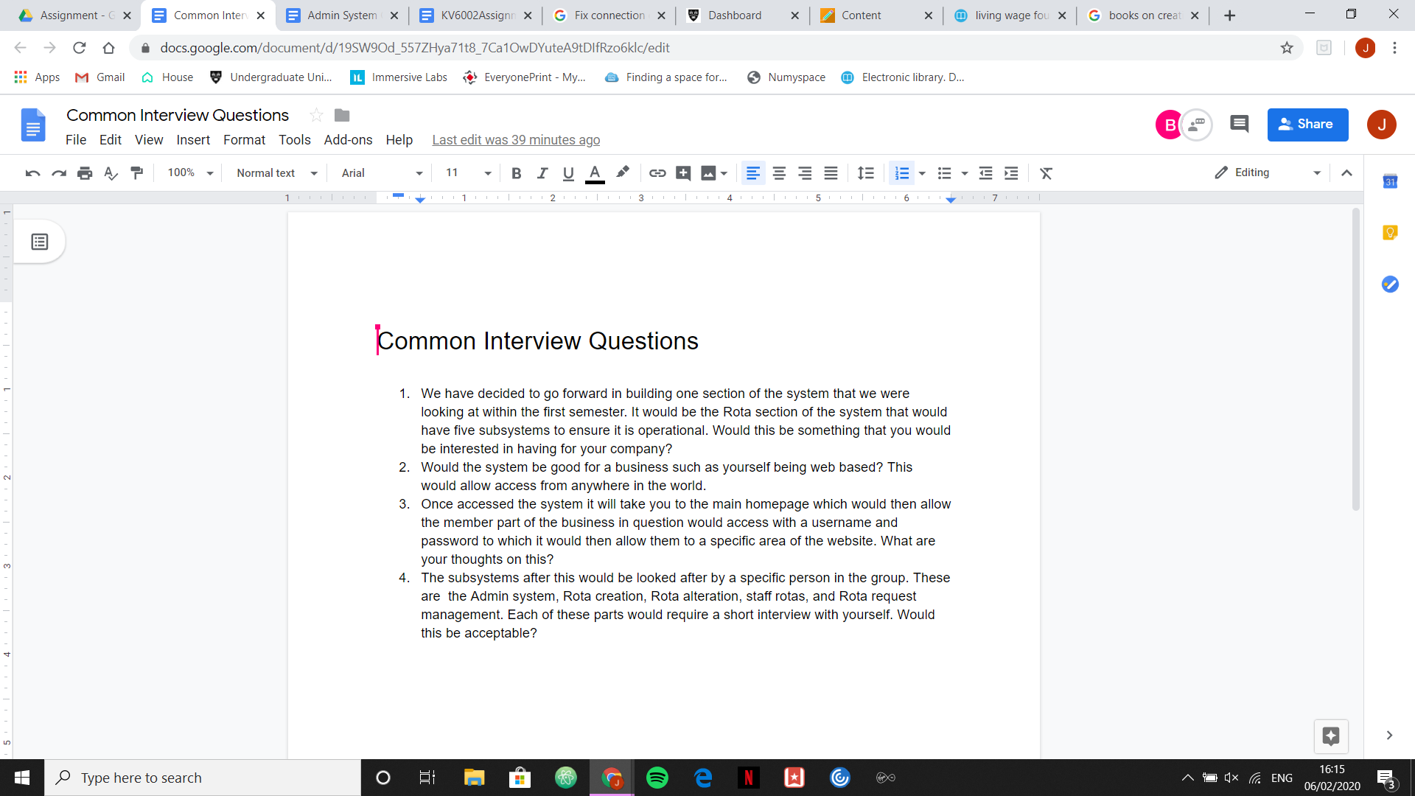

## 

## 

## 

## 

## 

## 

## 

## 6.2 Appendix B

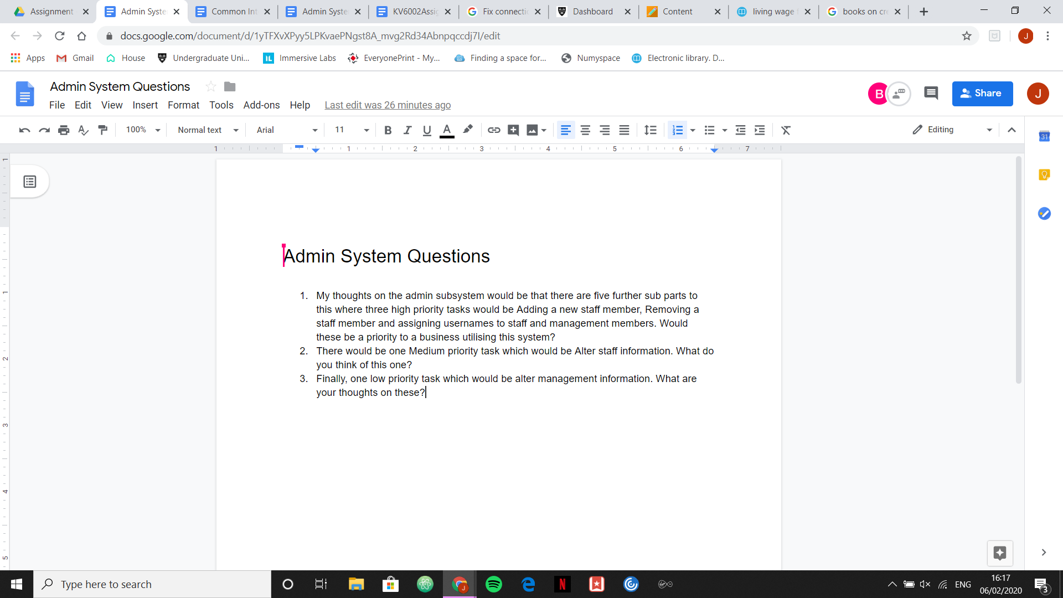

## 6.3 Appendix C

Create Rota Subsystem Interview Questions

These questions will provide the required detail that is needed to create a rota such as the amount of departments and the number of shifts each day.

* Can you explain how you currently create a weekly rota for the business?
* Are there any aspects of this you would like to change?
* How many different departments are within the business that need to be on each rota?
* How many shifts are needed for each department per day?
* Does the number of shifts change depending on the day of the week?
* What are the typical timings for each shift?

## 6.4 Appendix D

Rota Request Subsystem Interview Questions

* How do you currently approve or deny requests?
* How do you alert staff members if the request has been approved or denied?
* How many requests can you approve on a specific day?
* How much unpaid leave do you allow your staff to take?
* How many staff members do you allow to take a holiday at the same time?
* How many staff members are required on each working day and at specific times of the day?

## 

## 6.5 Appendix E

Staff Rota System Staff Questionnaire

Please circle at least one option from each question, please note that 1 is the lowest score and 5 is the highest score.

How efficient is the current staff rota system?: 1 2 3 4 5

How outdated would you say the current system is?: 1 2 3 4 5

How accessible is the current system? 1 2 3 4 5

Would you like to be able to access coworkers timetables?: Yes No

How many weeks in advance would you like your rotas to be published?: 1 2 3

Is there anything you would like to keep from the old system?

__________________________________________________________________________________________________________________________________________________________________________

Are there any recommendations you would like to put forward for the new system?

__________________________________________________________________________________________________________________________________________________________________________

## 6.6 Appendix F

Staff Rota System Interview Questions

When conducting an interview with management i will ask these questions to gather a further understanding of the business:

* Is your current staff rota system electronic?
* How many members of staff are currently employed?
* How many holidays can staff take?
* How many days off can staff have?
* What devices will staff be using when they’re on the app?
* Do you want other staff members to be able to access each other's rotas?
* How many weeks in advance do you want the rotas to be published?

## 6.7 Appendix G

Rota Alteration interview questions

* How much notice do you need to give staff before making changes to the rota?
* How would you like to notify staff when changes have been made?
* What is the main reason rotas are currently changed at the moment?
* Is there anything you would like to specifically include to make the system more functional for you?

## 6.8 Appendix H

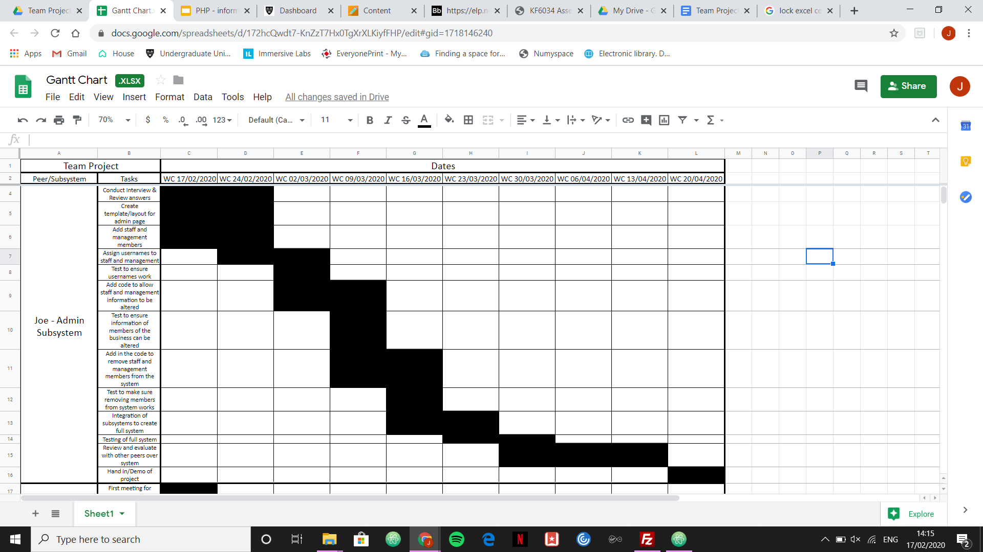

## 

## 6.9 Appendix I

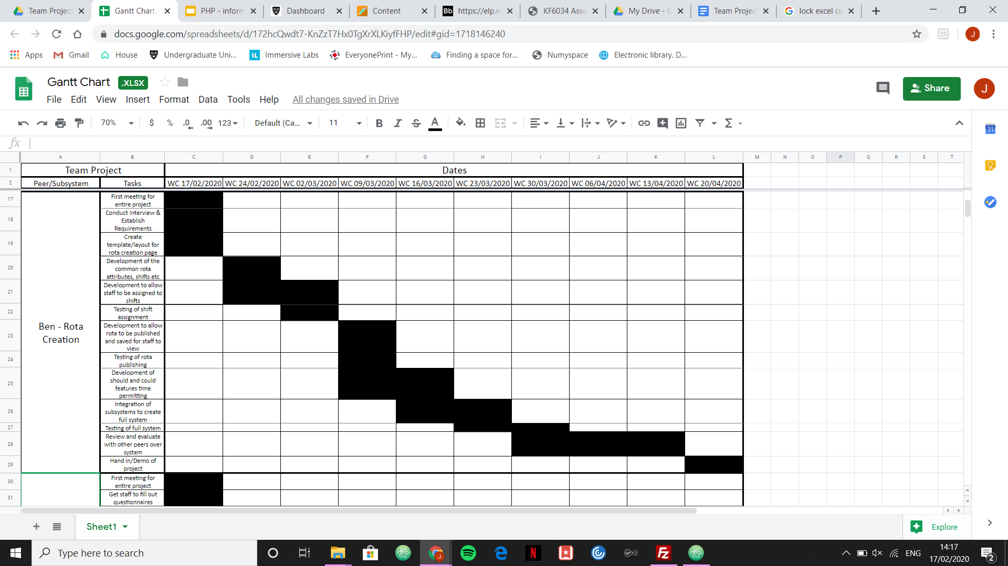

## 6.10 Appendix J

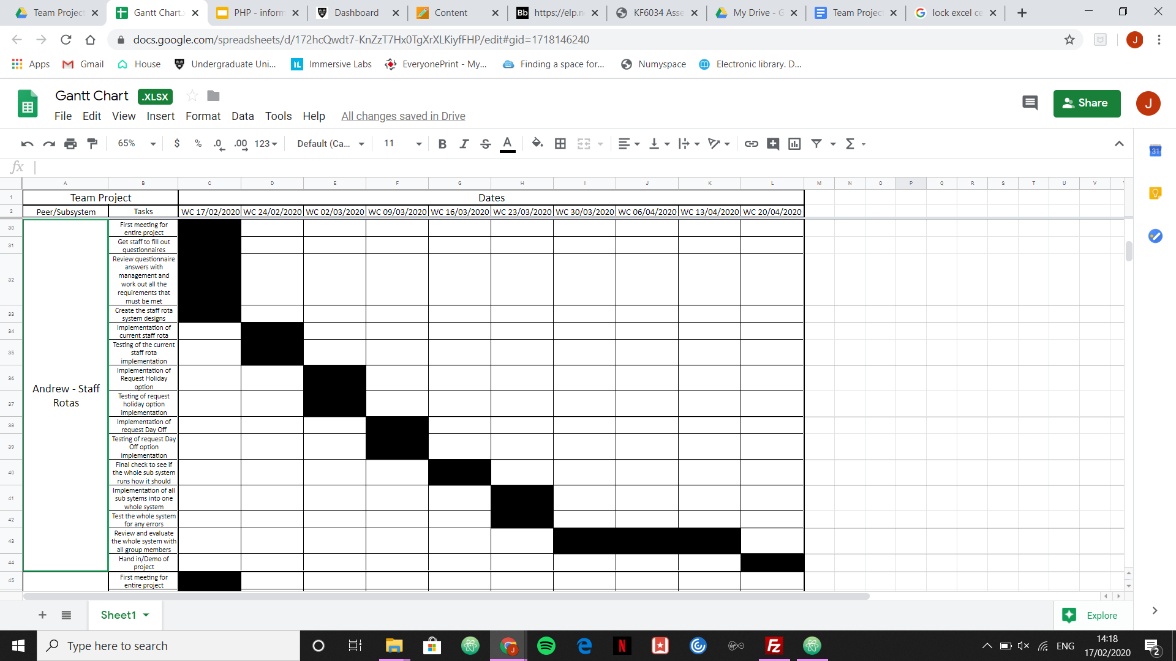

## 

## 6.11 Appendix K

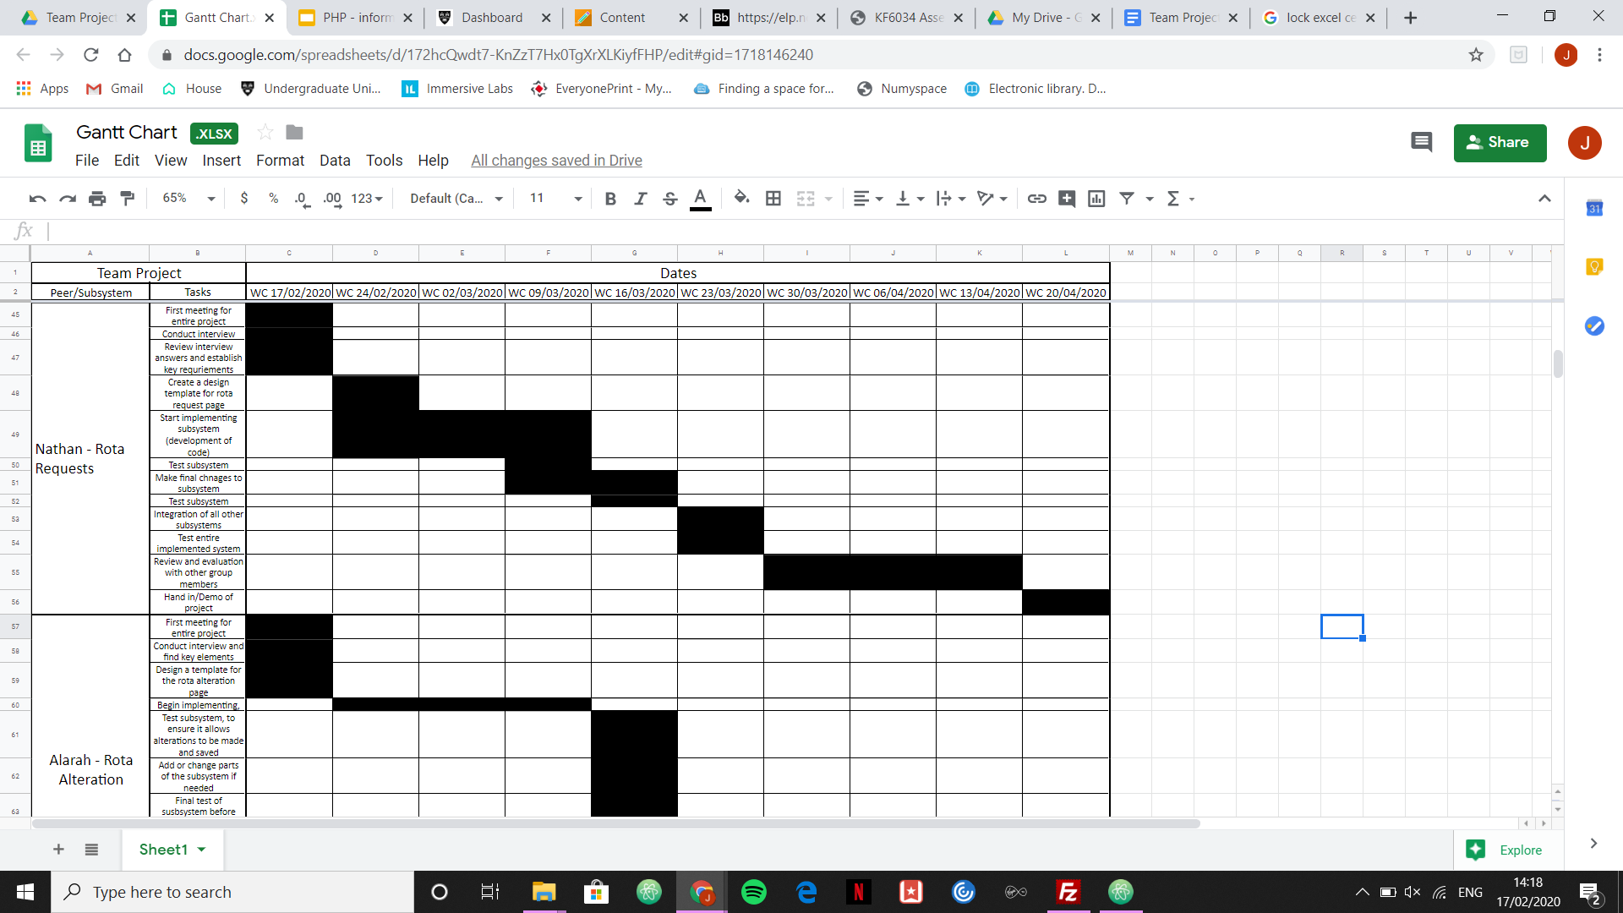

## 6.12 Appendix L

